Monticello (pronounced either män-tə-`sel-ō or män-tə-`chel-ō) “is a distributed optimistic concurrent versioning system for Pharo code source. It was written by Avi Bryant and Colin Putney, with contributions from many members of the Pharo community” (see <http://www.wiresong.ca/Monticello/>). So far we have been saving our code by saving the Pharo image. Monticello gives us much more powerful tools for managing source code.

1. 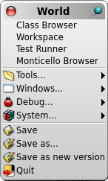Create a Monticello package.

Open your Pharo image that has the Los Boquitas application we have developed in earlier chapters. Open a Monticello Browser by left-clicking on the desktop and selecting ‘Monticello Browser.’

1. Create a Monticello Repository to hold the code.
   1. In your operating system create a directory to be used for Monticello packages. For now, consider something like ‘C:\Monticello’ or ‘/Monticello’ since it will be easy to find. (If you don’t want to clutter your root directory then you probably know how to pick a better spot!)
   2. With the LosBoquitas package selected, click on the ‘+Repository’ button (center). This will open a menu with a list of repository types. For now we will use a directory repository. Click on ‘directory.’

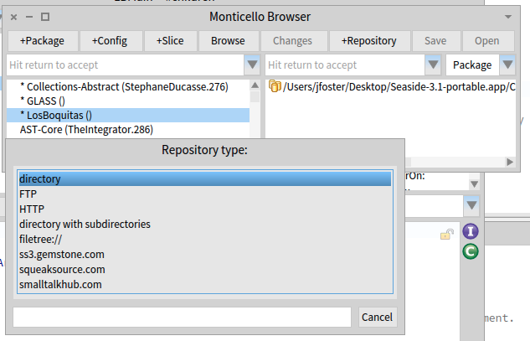

* 1. 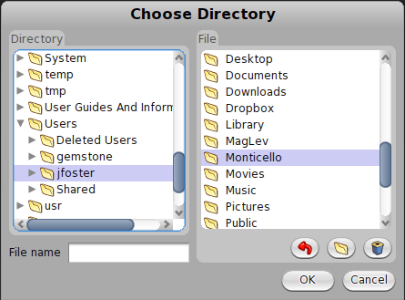This will open a folder selection dialog in which you can select the directory you created above. In this example, I’m on a Macintosh and have selected ‘/Users/ jfoster/Monticello’ as my folder.
  2. At this point the Monticello Browser should show the LosBoquitas package on the left and the directory repository on the right.

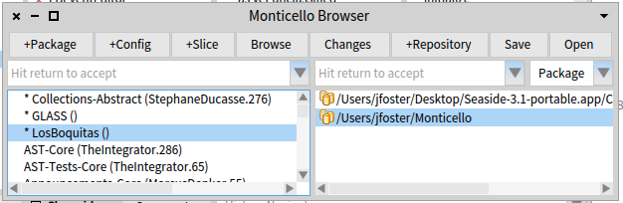

1. Save your code to the new repository.
   1. In the Monticello Browser, click the ‘Save’ button (the one in the center). This will bring up a dialog where you can edit the version name and a log message.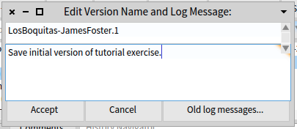
   2. Verify that the version name begins with ‘LosBoquitas-’, has your name (not mine!), and ends with ‘.1’ (the version number). Enter a log message in the text area and then click the ‘Accept’ button.
   3. At this point you should see a Version window (shown in front here) and the Monticello Browser should be updated with the current version name in the package list (shown behind the version window in this screen shot).

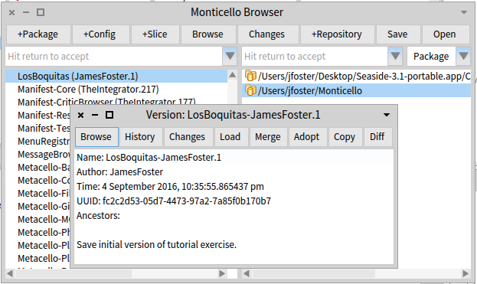

1. Using your native OS tools, navigate to the directory being used as the Monticello repository. You should see something like the following (depending on your operating system).

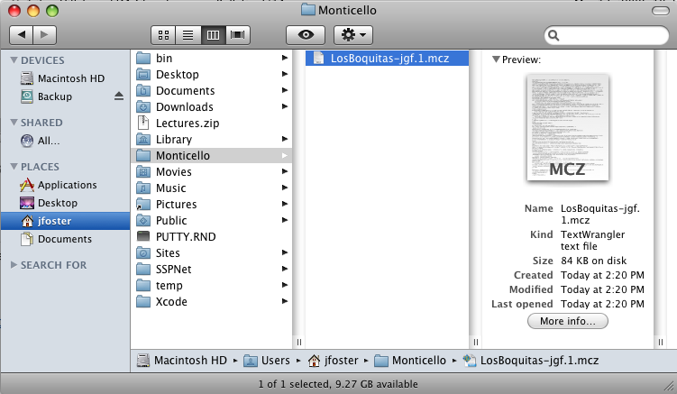

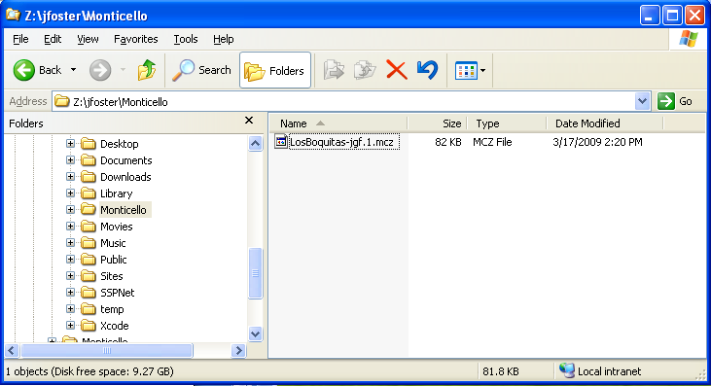

* 1. Duplicate the MCZ file and rename it with a ZIP extension (e.g., ‘LosBoquitas.zip’).
  2. Unzip the new file and view the contents. You should see three files and a directory in the new directory.

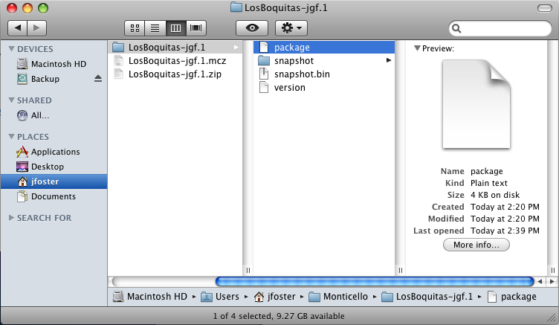

* 1. The ‘package’ file is a text file that contains the following:

(name 'LosBoquitas')

* 1. The ‘snapshot.bin’ file is a binary file used by the Monticello tools to load and compare packages.
  2. The ‘version’ file is a text file containing a full version history of the package. In our case the history is quite simple. In the following, the formatting has been changed to make the text more readable.

(

name 'LosBoquitas-JamesFoster.1'

message 'Save initial version of tutorial exercise.'

id 'acc13957-a73b-4112-a1d5-9152062a7e08'

date '12 February 2011'

time '8:05:10 pm'

author 'JamesFoster'

ancestors ()

stepChildren ()

)

* 1. The ‘snapshot’ directory contains a text file, ‘sources.st’ that is suitable for filing in to a Pharo image to generate the classes and methods in the package.

1. View changes using Monticello.
   1. Select a method in the LosBoquitas package and modify it. For this example, I’ve modified LBUser>>#’name’ to add a comment. Note that the Monticello Browser now shows an asterisk next to the package name.

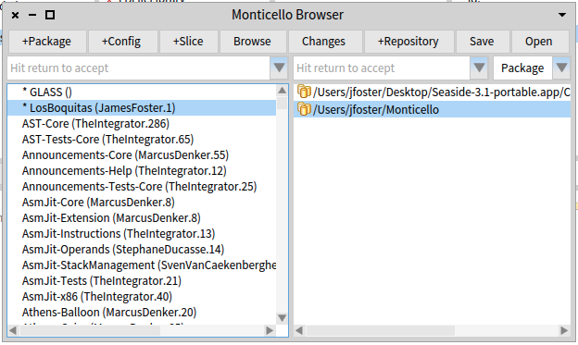

* 1. With a package and repository selected, click on the ‘Changes’ button to open a Patch Browser. The saved package contents are shown in red type and the new package contents are shown in green type.

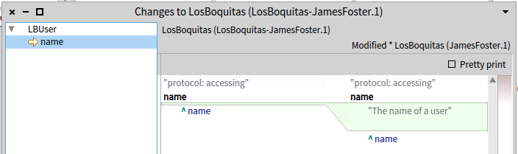

In subsequent chapters we will look at how Monticello can be used to transfer code from Pharo to GemStone.